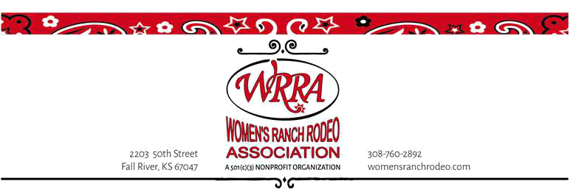
Jacque Harmon,
Vendor Chairwoman
jacque.harmon@yahoo.com
424 E. Mill Street
Plainville, KS 67663
womensranchrodeo.com
2022 World Finals Ranch Rodeo
Clarence L Brantley Indoor Arena
Pawhuska, OK
October 21-22 , 2022

Vendor Contract & Application
***Your completed application form, with your signature, will confirm to us that you have read and understood all the rules and regulations regarding the Women’s Ranch Rodeo World Finals.

The WRRA World finals is free to two people with your booth. You will receive two tickets when setting up.

Guidelines
- Exhibitors shall maintain the contents of their displays within their allotted space.
- Exhibitors shall conduct the operation of their booth in a respectful, quiet, and orderly manner at all times.
- This application becomes a binding contract when accepted by the WRRA.
- Final event details and load in instructions will be sent the week prior to the event via email.
- No refunds will be issued in the event of your cancellation after September 25, 2022.
- Exhibitors will be responsible for collection of any applicable sales tax.
- Exhibitors will agree to comply with local, city and state laws regarding fire laws.

Neither the WRRA, Clarence L Brantley Indoor Arena, Osage County Fairgrounds or any sponsor associated with the event will be responsible for any injury, loss, or damage.

Set up and Take down:

Set up:
Thursday Oct. 20th from 3:00pm-6:00pm
Friday Oct. 21st from 8:00am-9:00am

Take Down:
Saturday Oct. 22nd from 6:00pm-10:00pm

Hours of Operation

Friday Oct. 21st from 8:30am-9:00pm
Saturday Oct. 22nd from 10:00am-6:00pm

- There are camper hookups available at the facility.

Vendor Contract

COMPANY INFORMATION: Please make sure that the person listed as the representative-in-charge handles all behind-the-scenes arrangements, as all event details will be emailed to this person.

Representative-in-charge_____________________________ Title____________________________________________

Company_____________________________________________________________________________

Address_ _____________________________________________________ City_________________________________

State__________ Zip_________________

Telephone_____________________________________Email__________________________________

Web Address ____________________________________________________________________________________

FEES:

Indoor Vendor-
_____10x10 space $50 _____10x20 space for $100
Remember your own electrical cords, tables and chairs.

Outdoor Vendor $200
We want space for one of the following:
Our tent. Its dimensions are: __________________ x __________________ ft.
Our trailer. Its dimensions are: ________________ _x __________________ ft.
We will need electricity: Breaker size __________________ voltage requirement __________________

AGREEMENT: I have read and agree to comply with the vendor information and policies in this contract. I understand that by providing my email address and contact information I am authorizing WRRA to send information to my organization about upcoming events, programs, and services via these means.

Representative-in-charge____________________________ Title____________________________________________

Signature_________________________________________ Date _____________________________

PAYMENT INFORMATION: All fees to be paid in U.S. funds by September 25, 2022

___Enclosed is a check payable Women’s Ranch Rodeo Association

___Please send me a PayPal invoice.

Please Mail Payment and Contract to:

Jacque Harmon, WRRA
424 E. Mill Street
Plainville, KS 67663

